Thesis Parks requested amendments Paolo Vineis and Ben Armstrong
26 July 2019
General comment
The thesis is a valuable and original contribution to the literature but shows some weaknesses in epidemiological methods and in biological interpretation.
I thank the examiners for their insightful and useful comments. The main aim of my thesis was to create a statistical analysis capable of examining the dynamics of seasonal mortality, and how seasonal anomalous temperature might be associated with temperature, stratified by month, sex, and age group, over time and space. My thesis explains how temperature anomaly has a predictive value in its association with mortality, whether or not the association is directly causal, or indirectly causal via mediators.
To clarify, my thesis did not aim to use seasonality as a proxy for temperature. Rather, I aimed to explain year-to-year variation within season by temperature deviation from the long-term norm, which in my thesis I call temperature anomaly.
Chapter 4 (published in a paper in eLife) is a statistical analysis of the dynamics of seasonality, while Chapters 5-7 seek to explain the extra-seasonal variation in death rates at comparable times of the year (e.g., why death rates in January in one year would differ from January in the next year). I have added appropriate detail to the epidemiological methodology as well as further detailed biological interpretation.
Overall, my thesis focused on statistical methods and not causal inference. I am grateful for the changes you have proposed, which give the thesis a more rounded epidemiological and biological narrative. I have made the changes that you have specified, with some comments justifying the changes.
I have detailed the changes I have made below, with appropriate references to the text in the tracked version of the thesis
[[[Majid if the page numbers in comments are not correct please make sure setting is as below in the review tab. I cannot predict which setting you will see on opening due to a glitch in Word. Sorry]]]
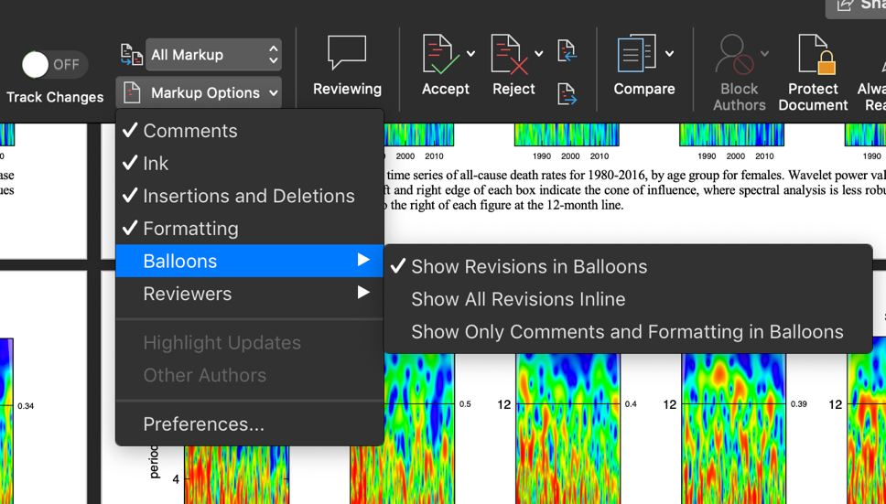
Amendments that need to be made
1. There is some confusion in the introduction to the main chapters and in the discussion about the meaning of basic epidemiological terms:
(a) the candidate should propose a formal definition of confounder for example at the end of Chapter 2. Then in substantive chapters (4 to 7) he should specify, based on his formal definition, what confounders might be at work for each analysis. He should identify potential confounders (measured and unmeasured) and note where the models control for these. His current tendency is to define confounders computationally (a posteriori), which is at odds with consensus epidemiological theory.
(b) in the same places he should define effect modifiers formally and then list potential ones of possible importance and note (if measured), if he has investigated that modification and if not why not.
(c) in the same places he should discuss briefly whether or not potential variables are in the causal pathways from temperature to outcomes and the implications of this
(d) these concepts should be finally considered in the Discussion of each substantive chapter in the context of a causal appraisal of the associations
As an example, when he states
“It has also been argued that pollution should not be a confounder of temperature mortality association, as adjusting for pollution excludes the interaction between temperature and pollution” he should be more analytical and discuss the potential role of air pollution as a confounder, as an intermediate variable in the causal pathway and as an effect modifier.
I have added definitions of confounders, effect modifiers and mediators, in Section 5.5 on pgs. XX-XX. I have also listed potential variables of note, and the implications of these on my study and potential future work, in Section 8.2 on pgs. XX-XX.
Chapter 4’s analysis is statistical and not based on causal inference. Therefore, I have not included a description of potential confounders in Chapter 4’s discussion.
2. There is no discussion of the role of cohort studies (e.g. ACS, ESCAPE) in the study of temperature and seasonality. Perhaps none has been published, but the issue should be discussed, with merits and limitations of such studies.
I have elaborated with the new Section 2.4.8 on pg. XX. I give a small comment in future work in Section 8.4 on pg. XX.
3. Season is mainly interpreted in the thesis as a proxy for temperature. It is not made clear what is in season that goes beyond temperature and that could confound the association between temperature and outcomes. For example, seasonal behaviours dictated by social norms (holidays) and not temperature, viral infections not caused driven temperature etc.
This should be discussed when introducing seasonality in Chapter 2 and then briefly in each of the substantive chapters where season is used, and in the general Discussion.
One of the main aims of the thesis, as mentioned in the main response above, was not to look at seasonality as a proxy for temperature, but rather to understand the role of temperature in interannual variation of death rates. To the extent that seasonal behaviours are dictated by social norms, the season itself (i.e., the absolute temperature characteristic of the season as well as the events which take place within it), is not analysed here, but rather the differences between the equivalent months in different years. This would remove the confounding effect of a holiday, for example, Christmas, as it always takes place within the month of December.
I have elaborated upon this point in Section 5.4.2 on pg. XX and in Section 5.4.6 on pg. XX.
4. In addition to the epidemiological methods, there are weaknesses in the biological interpretation of associations, both when appraising the literature and in the interpretation of his findings. For example, on page 35: acritical review of evidence of associations such as suicides. In Chapter 6: “Regarding suicide, higher temperature has been hypothesised as associated with higher levels of distress in younger people.” This is a very superficial explanation. The candidate should show awareness of his limitations in pathophysiological interpretations and the speculative nature of such discussions.
I have added to Section 6.6, emphasising the speculative nature of these pathways on pg. XX. I have also added to the discussion in Section 8.2 on pgs. XX-XX.
Regarding biological pathways for other causes of death, such as from cardiorespiratory diseases, I have given detailed descriptions of potential causal pathways. These descriptions can be found in Section 2.4.4 on pgs. XX-XX and in Section 7.6 on pgs. XX-XX.
5. There is no mention of internal migration, permanent and temporary (e.g., holidays) in the US, e.g. of elderly people moving from cold to warm States (typically Florida) after retirement. Are deaths attributed to the State in which the death occurred, that of their current main residence, or by some other criterion such as where resident in the last census. e.g. would deaths in retired “snow birds” from Vermont wintering in Florida be recorded as in Florida or Vermont? How would this affect misclassification and consequently your results?
The state of residence is where a death would be recorded. I have added a discussion about the potential impact of migration and ‘snow birds’ to the discussion in Section 8.2 on pgs. XX.

Minor
- Introduction: 6.6 degree increase by 2100? Level of confidence according to IPCC?
I have adapted previous wording to give an indication according to IPCC conventions in Section 2.2 on pg. XX.
- Note 130: “previous studies”? - this inference like others based on citing the literature is a little weak. We are not requesting a systematic review of the literature, but the candidate should be much more critical in his assessment of previous evidence and alleged causal inferences
I have elaborated with further sentences in Section 2.4.4 on pg. XX, and in general throughout the thesis.
- On displacement, PAGE 37
“Some speculate that this occurs when increased mortality occurs during elevated temperatures. The implication is that the increase in deaths would not necessarily be of public health significance, since the deaths were only slightly brought forward in time. A study of suicides found no mortality displacement when associating mortality with temperature.”
I am not persuaded: (a) displacement does have personal and familial implications (e.g. legacies, psychological preparedness, etc). Second, it is not only an empirical (data-driven) issue, but it needs to be also dealt with theoretically, i.e. as depletion of the most susceptible, before concluding that it is irrelevant.
I have added further discussion sentences in Section 2.4.7 on pg. XX.
- There is a very rapid description of the different Bayesian methods, but what are the respective advantages? (e.g., JAGS vs Gibbs etc)? Why certain methods have been used and not others? This is not clear to the non-statistical reader
I have elaborated with further discussion in Section 2.5.3 on pg. XX.
- “Cancer death outcomes are not generally considered as sensitive to temperature changes, and so are all grouped as ‘cancers’ here.” In fact, one could consider death anticipation in terminally ill patients (many) and in certain types of cancer that are likely to increase susceptibility to temperature (e.g. leukaemia)
I have elaborated with further discussion in Section 3.2.5 on pg. XX.
- “A limitation of my results in Chapters 4, 6 and 7 is that I did not investigate seasonality of mortality by socioeconomic characteristics which may help with understanding its determinants and planning responses”. This is an interesting comment and the candidate could explain how the impact of temperature on health outcomes might vary by SES based on other data.
I have added further discussion in Section 8.2 on pg. XX.
- The thesis does not consider infectious diseases (too few deaths?). This should be discussed.
It is correct to point out that there are too few deaths for infectious diseases. I have added a sentence to make that explicit in Section 3.2.5 on pg. XX.

